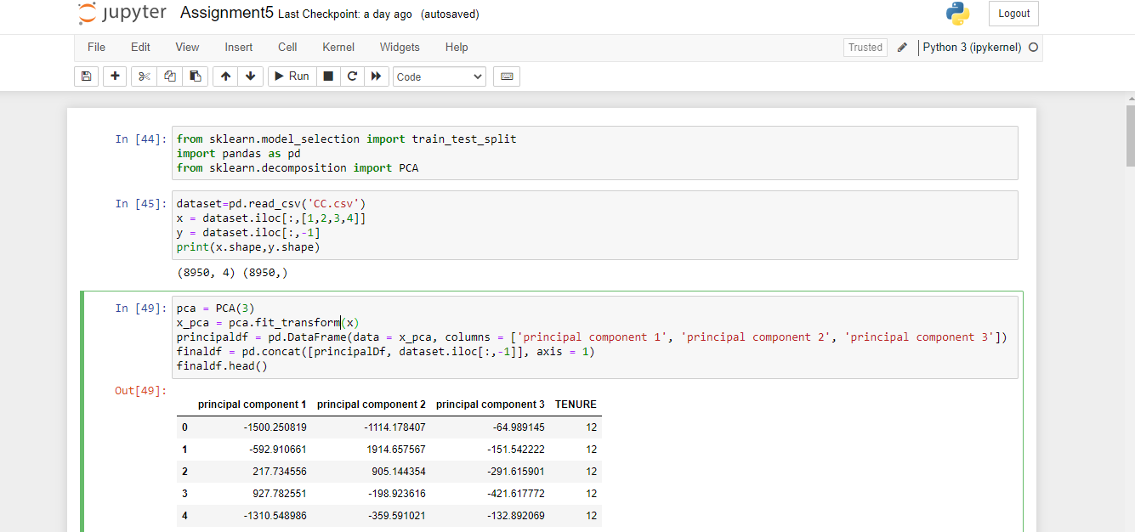

Applied PCA on CC dataset

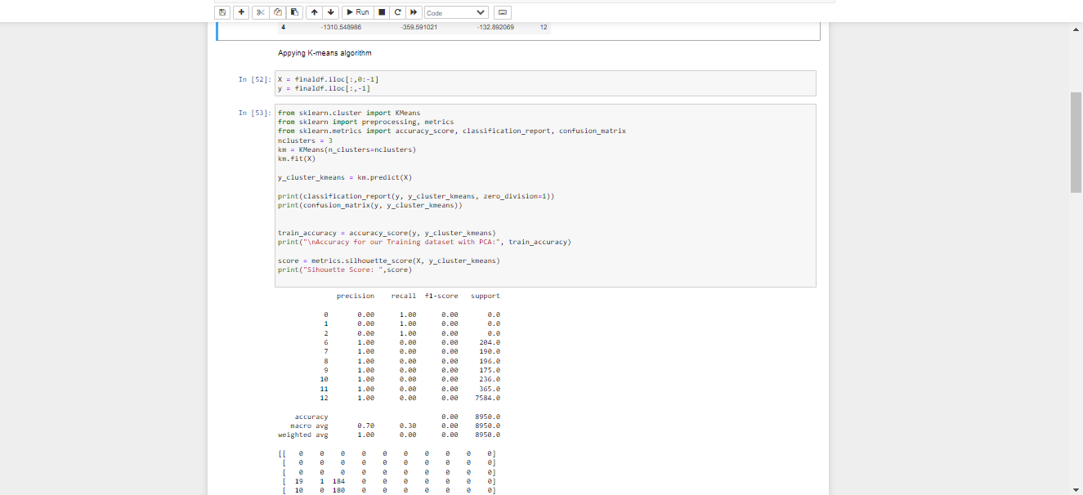

Applied k-means algorithm on the PCA.

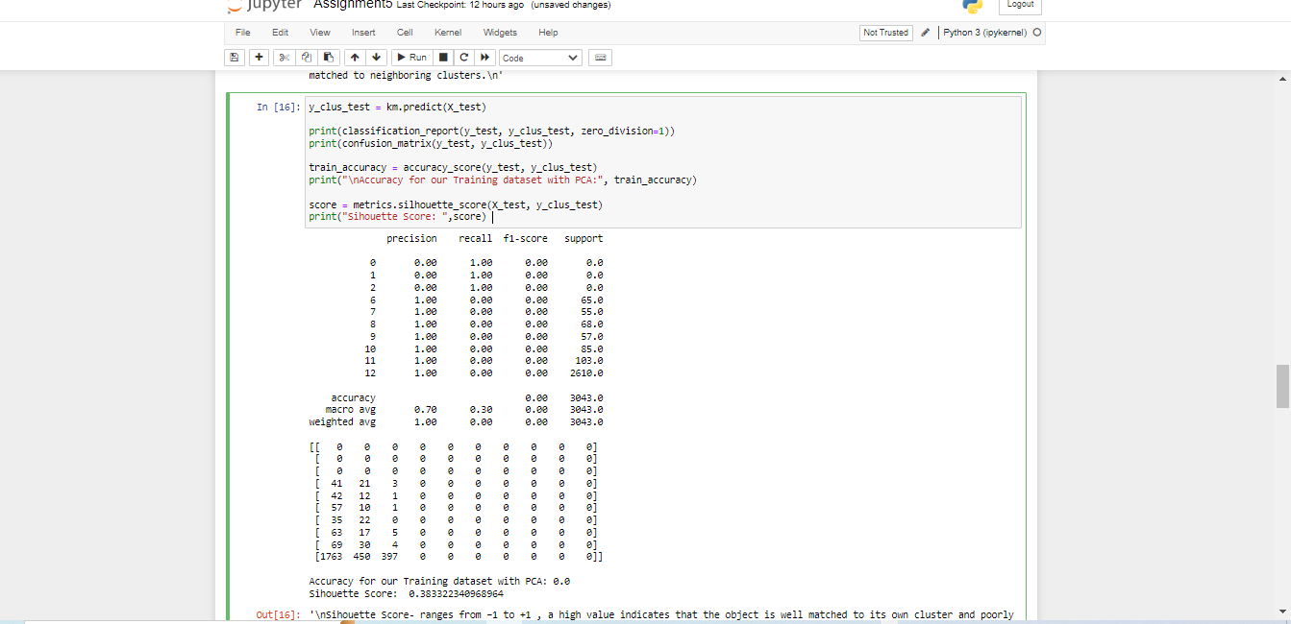

The Silhouette score in PDA is near to 1, while the Silhouette score in K-means clustering is near to 0 when compared with PDA. Hence it does not improve Silhouette score.

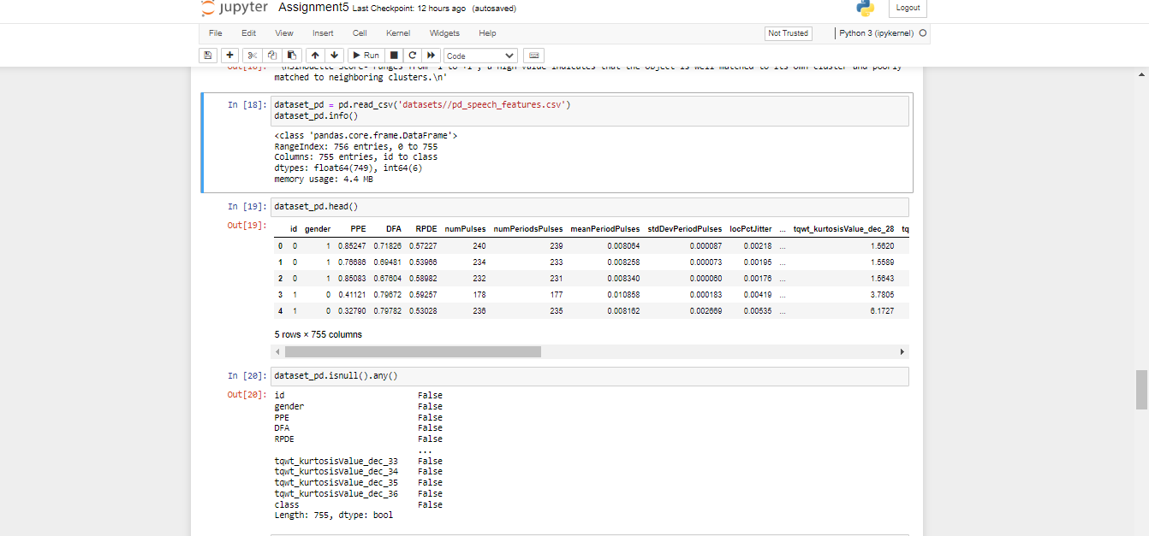

Performed scaling

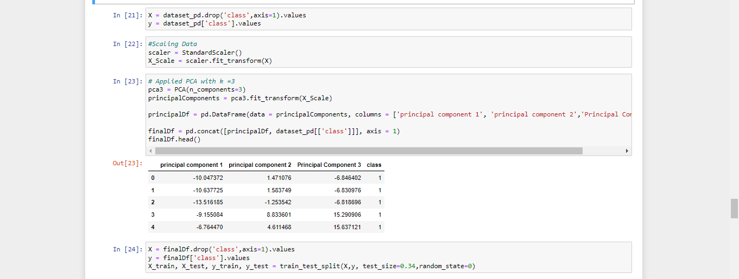

Scaling the features makes the flow of gradient descent smooth and helps algorithms quickly reach the minima of the cost function. Without scaling features, the algorithm may be biased toward the feature which has values higher in magnitude.

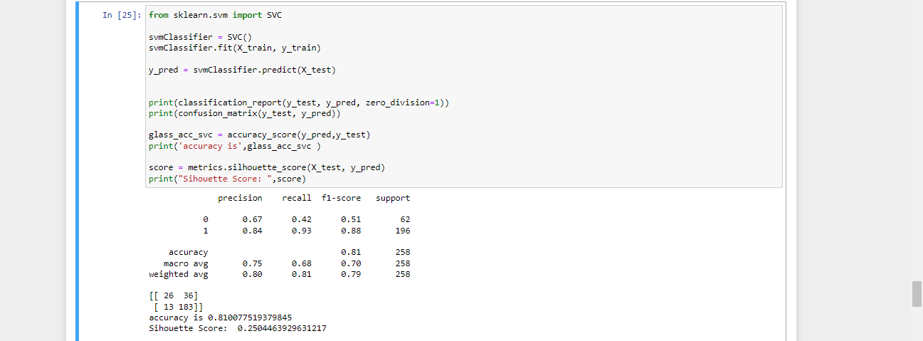

Applied Linear Discriminant Analysis (LDA) on Iris.csv dataset to reduce dimensionality of data to k=2

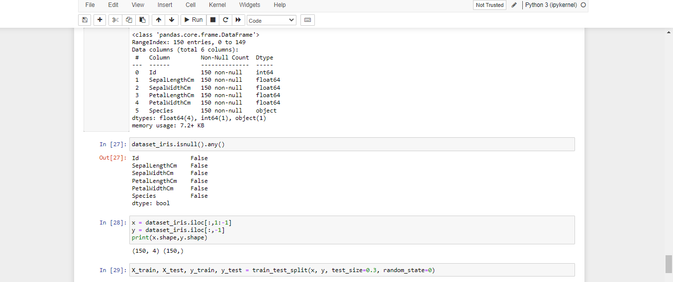

LDA assumes examples within one class or the other are normally distributed, and from their means/variances you can analytically determine a best separating hyperplane between the classes.

Principal component analysis (PCA) is a dimensionality-reduction method that is often used to reduce the dimensionality of large data sets, by transforming a large set of variables into a smaller one that still contains most of the information in the large set.